Part B: Nervous system function (17 marks)
Jenny had surgery to set her broken bone; this was done under general anaesthesia.
The unlabelled graph of the action potential phases has been provided to assist with your answers

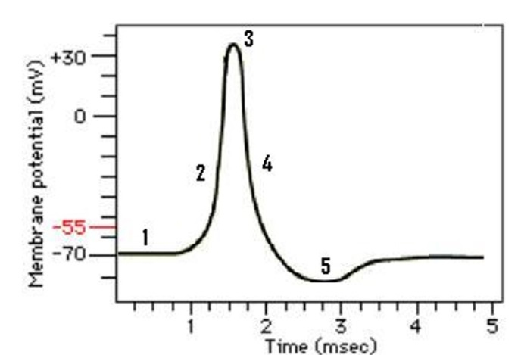

- When nerve cells are at rest, there is a resting membrane potential (RMP; phase #1 on graph) for the neuron cell membrane. Describe how the RMP is generated. (3 marks)

- Jenny is conscious and alert when certain neurons in her brain are active. Her neurons depolarise, produce action potentials, repolarise and hyperpolarise. Define depolarization and hyperpolarization and explain their relationship to threshold. (3 marks).

- Jenny’s nerve cell membranes have both leak (passive) potassium channels and voltage-gated potassium channels. Explain how these channels differ, in terms of where in the cell they are located and in how they work. (3 marks)

- Anaesthesia to be used for Jenny’s procedure will affect her neurons for consciousness and sensation of pain. The anaesthetic acts by opening more potassium leak (passive) channels. How does this make Jenny’s neurons less likely to produce the action potentials that would normally keep her awake and experience pain? (3 marks)

- Skeletal muscle has similar types of potassium leak (passive) channels that react with the general anaesthesia. What might be the effect on Jenny’s skeletal muscle contraction during surgery? Explain. (2 marks)

- Prior to surgery, Jenny’s pre-op blood testing revealed hyperkalaemia (indicated high levels of extracellular potassium. What effect would elevated extracellular potassium have on muscle and nerves cells? (3 marks)

Part C: General questions on Nervous System Function (6.5 marks)
1. In terms of nerve communication,
a. Why might a patient experience sensations of tingling and numbness in their lips/tongue/face/neck? Suggest possible steps in nerve transmission that may be affected (3 marks)

b. Suggest likely affected peripheral nerves that may cause paralysis in the face and mouth; Justify your choice. (3.5 marks)

Part D: Skeletal muscle function (24.5 marks)
You will need to research this topic.
Search terms and topics: Malignant Hyperthermia (MH); Ryanodine (RyR) receptors; Halothane binding to variant RyR1 receptor.

Brian Wilson is an 18-year-old male student who was healthy until two days ago when he experienced severe abdominal pain, fever, and vomiting. A visit to his GP revealed that he had acute appendicitis. Brian is in excellent health but during the surgery, his body temperature began to rise quite quickly. Medical staff managed this emergency and later diagnosed a genetic condition called Malignant Hyperthermia (MH) that causes a rapid rise in core body temperature, severe muscle contractions and respiratory distress under general anaesthesia (with Halothane).

- How do Brian’s skeletal muscles contribute to his body temperature? (2 marks)

- In a normal muscle cell, describe the sequence of events and cell locations that lead to calcium release for contraction. (4 marks)

- During Brian’s sedation, Halothane anaesthetic caused an adverse effect by binding with Brian’s variant RyR1 ryanodine receptor located in his skeletal muscle cells. At what location in Q2 did this occur? Explain what happened at the molecular level that caused the severe muscle contractions. (4 marks)

- This MH condition causes a hypermetabolic state in skeletal muscle, which is triggered by high demands for ATP during uncontrolled muscle contractions.

- Explain what “hypermetabolic” means. (1 mark)

- Discuss the impact of the hypermetabolic state on chemical demands and adjustments to metabolism in Brian’s skeletal muscle cells. (10 marks)

- How does ATP contribute to maintaining calcium concentration gradients in muscles? (1.5 marks)

- Suggest a likely mode of action for a drug to reduce excessive skeletal muscle contraction during in any future procedures where Brian needs anaesthesia. (1 mark)

- What effect do you expect this drug would this have on Brian’s body temperature? Why? (1 mark)

